**Prison Management System**

**Software Requirement Specification**

**Version: - 1.0**



**Team Guide: - Team Members:-**

Mrs.Deepa Modi Sameep Periwal

Uday Chopra

Shumayala Sabbag

SKIT College Ritwick Tak

Computer Science Department

Jaipur

**Table of Contents**

**Description**

1. Introduction
   1. Purpose
   2. Scope
   3. Definitions, Acronyms & Abbreviations
   4. References
   5. Technologies to be used
   6. Overview
2. Overall Description

2.1 Product Perspective

2.2 Software & Hardware Interface

* 1. Product Features
  2. Constraints
  3. Use Case Model Description
  4. Use Case Diagram
  5. Class Diagrams
  6. Database Design
     1. DF Diagrams
     2. ER Diagrams

**Software Requirement Specification**

1. **Introduction**
   1. **Purpose:**

Prison management system provides facility of managing all the records of

prison over internet, which reduces paper work. It also includes Face Recognition

System to match achieved photo graph with photographs in database.

* 1. **Scope:**

**Basic features:**

•   Create different system users and assign different roles with related

Permissions

•   Track all the visitors their contact details.

•  Track all the staff, non-staff and prisoner in out details.

•  Track the Fund allotment and expenditure details.

•  All activities performed by the system users will be maintained in the form of

logs for auditing and maintaining the integrity of the system.

• Maintain a centralized database to provide security to information which can

be accessed only by the admin.

• Face recognition is included.

* 1. **Definitions, Acronyms, Abbreviations:**

PMS

Prison Management System: - It’s a web application that provides Prison Management System for Prisoners.

Admin

Administrator: - He has the authority to add/delete prisoners and grant privailages.

UML

Unified Modelling Language: - It is standard language for writing software blueprints. The UML may be used to visualize, specify, construct & document.

HTTP

Hypertext Transfer Protocol: - It is a service protocol.

HTML

Hyper Text Mark-up Language: -It is standard language used to create web pages.

CSS

Cascaded Style sheet: - It is a style sheet used for describing the look & formatting of a document written in a mark up language. While most often used to style web pages & interfaces written in HTML & XHTML, the language can be applied to any kind of XML document, including pain XML, SVG & XUL.

RSA

Rational software Architect

JSP

Java server page is a standard part of the J

EE.It is used to create dynamic web pages.

J2EE:

Java 2 Enterprise Edition is a programming platform part of the Java Platform for developing and running distributed multi-tier architecture Java applications,based largely on modular software running on an application server.

GUI:

Graphical User Interface with the system with mouse control and other easy to use control features like the menus etc.

Eclipse/NetBeans:

Development tool(IDE) for Web applications.

Servelets:

These are small programs which execute on the server side and dynamically extend the functionality of the web browser.It generally acts as a control in the server side.

* 1. **References:**
* Internet
* IBM – www.ibm.in/developerworks.
* Instructor
* Software Engineering, fourth edition, Roger S. Pressman.
* Object Oriented Modelling and Design with UML-Michael Blaha James Ranbaugh

**1.5. Technologies to be used:**

* XHTML
* CSS
* Visual studio 2010
* SQL server
* J2EE
* DB2
* JAVA

1. **Overall Description:**

The Overall Description section, of this document gives an overview of the functionality of the product. It describes the informal requirements and is used to establish a context for the technical requirements specification.

* 1. **Product Perspective:**

The web pages (XHTML/JSP) are present to provide the user interface on customer client side.Communication between customer and server is provided through HTTP/HTTPS protocols.

The client software is to provide the user interface on system user client side and for his TCP/IP protocols are used.

* 1. **Software & Hardware Interface:**

We must internet explorer to able to browser and show an interest Prison Management System, it must be pc computer to link to Prison Management System.

Minimum Requirements

|  |  |  |  |  |
| --- | --- | --- | --- | --- |
| **Client Side** | | | | |
| **Browsers** | **Operating System** | **Processor** | **RAM** | **Disk Space** |
| Internet Explorer - 6 | Windows XP | Intel Pentium 4 | 256 MB | 1 GB |

|  |  |  |  |  |
| --- | --- | --- | --- | --- |
| **Server Side** | | | | |
| **Software** | **Operating System** | **Processor** | **RAM** | **Disk Space** |
| Microsoft Visual Studio 10 | Windows XP | Intel core 2 duo | 512 MB | 5 GB |
| MY SQL Server Enterprise Edition 2008 | 512 MB | 10 GB  (Excluding Data Size) |

* 1. **Product Features:**
* Information is available anytime
* High integrity and Security
* Internal email
* User Authentication
* Help
* User Friendly
* Fully automated
* Duplicate of information curbed
* Instructor Helpdesk
* Ability to incorporate newly available data
  1. **User Case Description:**

Every user must be computer literate and he should have basic knowledge of

English.

* 1. **Constraints:**

1. Internet connection must be needed.
2. Registration is required for identification
3. GUI is only in English.
4. Limited to HTTP/HTTPS.
5. This system is used for single server.
   1. **Use Case Model :**

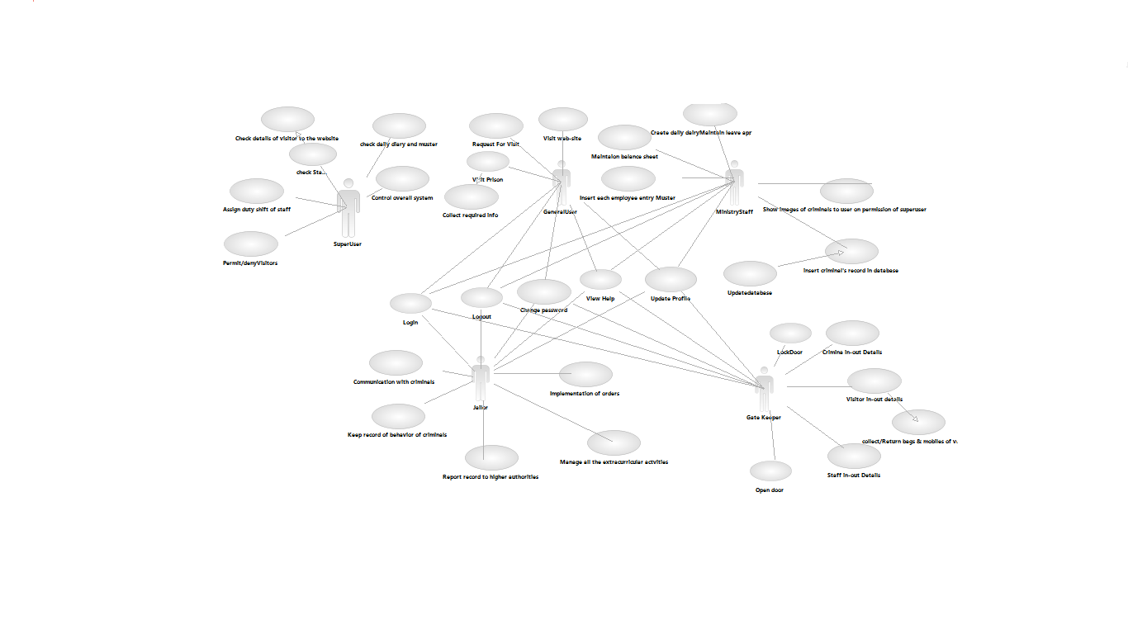

* 1. **Class Diagrams:**

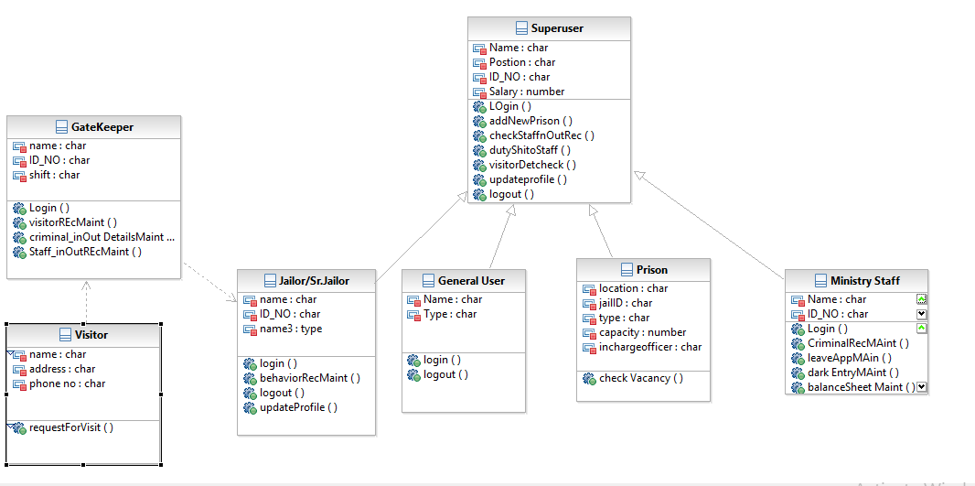

* 1. **Database Design**
     1. **DFD**

**LEVEL 0 DFD:**



**LEVEL 1 DFD:**









* + 1. **ER Diagram**

supervisor

Admin

Have

jailor

Work Section

has

prisoner

has



THANK YOU